**Tomahawk Area Interfaith Volunteers Annual Fundraiser**

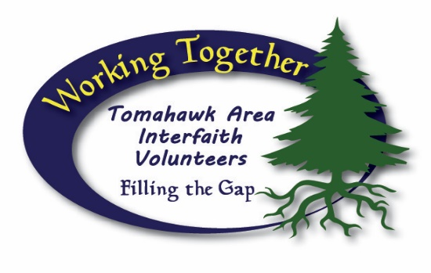

**2025 Golf Scramble Sponsorship Sheet, July 19th**

$200 per Team (includes 9 Holes, Cart, Lunch) Reg. 9am – Shotgun Start 10am

**Sponsorship Opportunities:**

**Event Sponsor # $1,000** ______________________

Logo on all posters along with logo on Website page, Social Media, Score Cards, also mentions on or in any kind of public interviews or articles and awards ceremony.

**Event Sponsor #2 $500**________________________

Logo on Website page, Social Media Page, Hole Sponsor also mentions on or in any kind of public interviews or articles and awards ceremony.

**Sandtrap Sponsor $150**________________________

**Hole Sponsor $150 x8**___________________________

Sign by sandtrap or chosen hole indicating your sponsorship, acknowledgement on website page and a mention and thankyou when the hole prize is awarded.

**Please write Clearly**

Sponsor Team

#1________________________________________________________________

#2________________________________________________________________

#3________________________________________________________________

#4________________________________________________________________