**Tomahawk Area Interfaith Volunteers Annual Fundraiser**

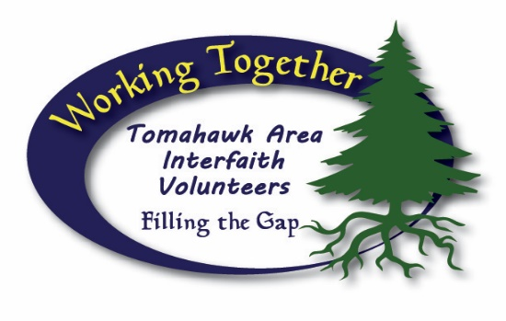

**2025 Golf Scramble, July 19th**

$200 per Team (includes 9 Holes, Cart, Lunch) Reg. 9am – Shotgun Start 10am

**Please write Clearly**

**Team Registration**

Name______________________________ Phone_______________________

Adress____________________________________________________________

Name______________________________ Phone_______________________

Adress____________________________________________________________

Name______________________________ Phone_______________________

Adress____________________________________________________________

Name______________________________ Phone_______________________

Adress____________________________________________________________

Registration - Amount Paid $________